JSPM’s RAJARSHI SHAHU COLLEGE OF ENGINEERING



**DEPARTMENT OF COMPUTER ENGINEERING**

**“Topic: Algorithmic Trading”**

**Name Of The Students: Shubham Jathar, Ajinkya Jadhav, Viraj Govilkar , Nikhil Shingade.**

**Name Of the Guide: Prof. Ashwini Bhosale**

**Academic Year:2023-24**

**Introduction:** Investment in the stock market is quickly growing day by day since it is the most advantageous enterprise in the modern world. The main trading venue was the stock market before computers and artificial intelligence were developed (AI). As a result, investors are looking for tools that will enable them to engage in profitable ventures, increase their returns, and lower their risk of financial loss. Trading and investment are at an all-time high as share market investing grows quickly. To anticipate the price of stocks, a variety of methods, including those based on statistical analysis, technical analysis, fundamental analysis, time series analysis, chaos theory, and many more, are being created. While several theories are employed, none of them are capable of accurately predicting the stock price since the predictive model has a low accuracy rate. The Artificial Neural Network (ANN) should function with the best accuracy and anticipate the proper Stock market price, but these types of theories don't operate very well.

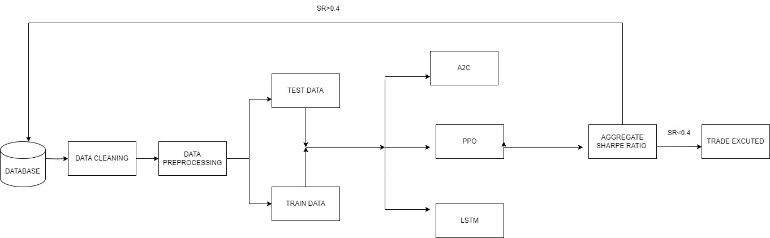 **System Architecture: Methodology:**

**Conclusion:** In the context of stock trading, the use of several trading systems, including Bollinger Bands, Moving Average Crossover, Relative Strength Index (RSI), and the Kelly Criterion, demonstrated encouraging outcomes. Every strategy exhibited its effectiveness in identifying unique market signals, adding to a collective approach that sought to capitalize on the advantages of each model while minimizing its drawbacks. It was shown that combining these tactics in an ensemble framework could improve overall performance and robustness. One of the group's main strengths was its capacity to adjust to shifting market conditions, as each of the many techniques worked well together to create a thorough trading strategy.

Name of the students: Ajinkya Jadhav, Nikhil Shingade, Shubham Jathar, Viraj Govilkar || Name of Guide: Prof. Ashwini Bhosale